**Settings for project configuration to compile and test all files in the project:**

1. Get the files from GitHub.

Purvi@DESKTOP-6NDUR2E MINGW64 /c/Data/Selenium_Project/Selenium_project (Subarna)

$ git checkout Deepali

Switched to branch 'Deepali'

Purvi@DESKTOP-6NDUR2E MINGW64 /c/Data/Selenium_Project/Selenium_project (Deepali)

$ ls

Readme.txt

Purvi@DESKTOP-6NDUR2E MINGW64 /c/Data/Selenium_Project/Selenium_project (Deepali)

$ git pull

remote: Counting objects: 8, done.

remote: Compressing objects: 100% (7/7), done.

remote: Total 8 (delta 2), reused 7 (delta 1), pack-reused 0

Unpacking objects: 100% (8/8), done.

From https://github.com/pKpallavi/Selenium_project

2619ab4..8a8eb11 Deepali -> origin/Deepali

ad7b409..775dc19 Subarna -> origin/Subarna

There is no tracking information for the current branch.

Please specify which branch you want to merge with.

See git-pull(1) for details.

git pull <remote> <branch>

If you wish to set tracking information for this branch you can do so with:

git branch --set-upstream-to=origin/<branch> Deepali

Purvi@DESKTOP-6NDUR2E MINGW64 /c/Data/Selenium_Project/Selenium_project (Deepali)

$ ls

Readme.txt

Purvi@DESKTOP-6NDUR2E MINGW64 /c/Data/Selenium_Project/Selenium_project (Deepali)

$ git branch --set-upstream-to=origin/Deepali Deepali

Branch Deepali set up to track remote branch Deepali from origin.

Purvi@DESKTOP-6NDUR2E MINGW64 /c/Data/Selenium_Project/Selenium_project (Deepali)

$ git pull

Updating 08c20ca..8a8eb11

Fast-forward

downloadbrochure.java | 79 +++++++++++++++++++++++++++++++++++++++++++++++++++

1 file changed, 79 insertions(+)

create mode 100644 downloadbrochure.java

Copy all Deepali’s files in the /c/Data/Selenium_Project/Selenium_project to C:\Users\Purvi\Documents\NetBeansProjects\Selenium_Project\src\test\java\test folder

In same way set upstream to track another user’s branch to check out their files and copy in your NetBeans test folder. The files are automatically updated in NetBeans IDE as test folder is set in your IDE configuration.

1. Right click on the project in NetBeans. Select Customize option.

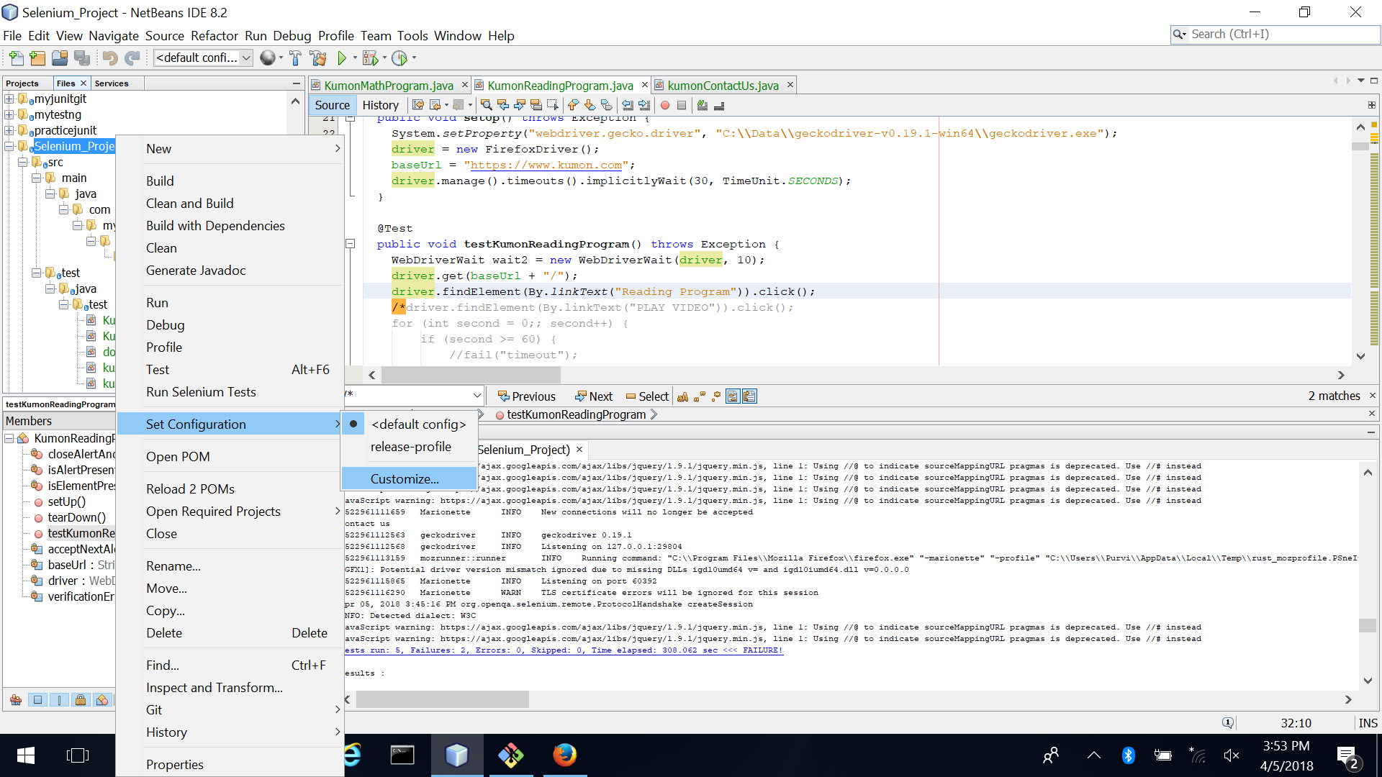

1. Select Actions and Test project in default config. Add goals as shown in snapshot below.

test-compile surefire:test

Set Properties as shown

test=*

Click OK.

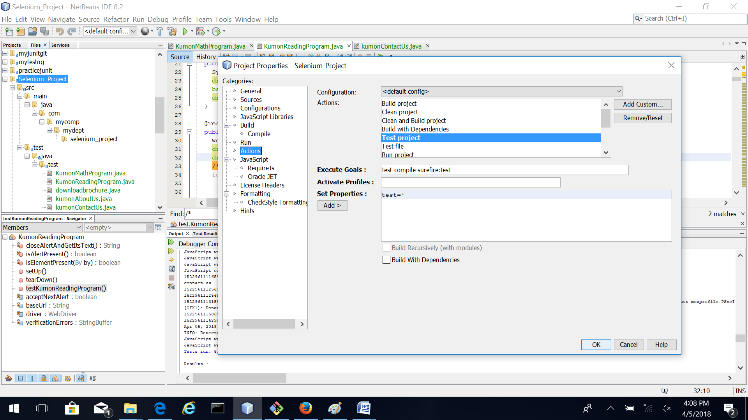

1. Right click on project and click Test

